

BREAK FREE

*“Close the door & race the clock”*

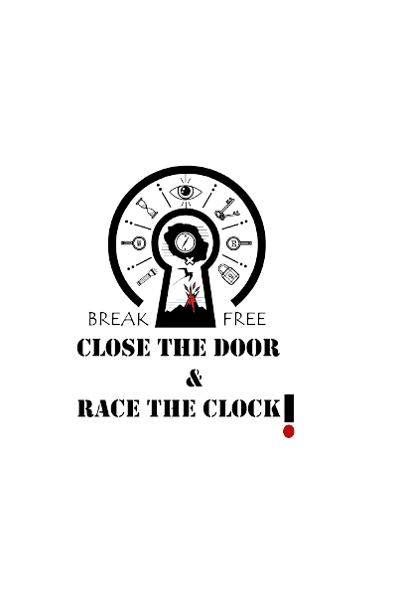

Module: Systems Analysis and Design

21CSIS01I

Module Leader: Prof. Nahla Barakat

|  |  |  |
| --- | --- | --- |
| Name | ID | E-mail |
| Rahma Abdulla | 196192 | Rahma196192@bue.edu.eg |
| Yasmine Sameh | 206197 | Yasmine206197@bue.edu.eg |
| Alaa Ouda | 179280 | Alaa179280@bue.edu.eg |

Table of Contents

1 Game Overview: 3

1.1 Game Genre: 3

1.2 Target Audience: 3

2 Dramatic elements of the game: 4

2.1 Main characters: 4

2.2 Boundaries: 7

2.3 Detailed Story: 8

3 Formal elements 9

3.1 Mechanics: 9

3.1.1 Player interaction pattern: 9

3.1.2 Goals: 10

3.1.3 Rules: 11

3.1.4 Primary actions and interactions: 12

3.1.5 Challenges: 21

3.1.6 Resources: 21

3.1.7 Player Mode Sketches: 22

3.1.8 Audio: 24

3.1.9 Outcome: 24

4 Dynamic Elements: 25

4.1 : 25

4.2 : 25

4.3 : 26

4.4 : 32

4.5 : 36

# File:BUE Logo.png - Wikimedia CommonsGame Overview:

* 1. Game Genre:
* (Adventure, puzzle, action) Hybrid game
  1. Target Audience:
* From 10 years old to 30

1. **Dramatic elements of the game:** 
   1. **Characters**:

* **Zoey** an introvert genius physics student at her early-20s who suffered a major depression mental state; she was diagnosed almost immediately after her mother died in a plane accident; in which she was the only survivor, her mother was the plane pilot, they were headed to Paris to meet her father when they start fighting; her mother lost control over the plane and they crashed killing everyone except Zoey. Zoey ones was a joyful, thrilled, cheerful, youthful young lady however, her mental state made her always anxious, sad, hopeless, guilty, irritable, empty. Zoey is a skinny, young, brown-skinned lady with light brown eyes. Zoey have an extreme ability of focusing, an outstanding ability in solving riddles, her level of intelligence is extraordinary.
* **Jason** a brave, greedy stockbroker in his mid-40s who was a solo survivor in a shipwreck, killed his only friend to survive that accident, at first he and his friend were the only two remaining from that shipwreck they stayed in the freezing water for 3 days hanging on a wooden piece of the wrecked ship, the weather was stone-cold; his friend had a jacket he didn’t; after staying in the freezing water for approximately 72 hours with light clothes, they started fighting over that jacket; he ended up killing his only friend. Jason is a tall, skinny, light-skinned man with dark brown eyes. He is a brilliant strategy maker; his experience with freezing weather made him a cold tolerant.
* **Ben** a left out, cowered butler in his late-20s who was the only survivor in a car accident, in which he was the driver; he lost his brother and 3 of his friends; they were going out to celebrate his brother’s graduation from collage. It was after midnight he was speeding up exceeding the legal limit of speed when suddenly an old woman appeared in front of the car in order to avoid her, he crashed into a large barrier filler with gunpowder that cause the car to explode, miraculously he survived that huge blast. Ben is a short, slim, longhaired man with bright green eyes. Ben has the ability to memories things very easily.
  + 1. . **Non-Playing characters:**
* **Amanda** an Iraq War veteran who survived an IED blast; she is a brave, strong, unbeatable, competitive, confident lady in her mid-30s, she suffered from a PTSD (post-traumatic stress disorder) “a mental health condition that's triggered by a terrifying event — either experiencing it or witnessing it. Symptoms may include flashbacks, nightmares and severe anxiety, as well as uncontrollable thoughts about the event.”, she has scares allover her body from the explosion, she is tall, white skinned lady, with dark green eyes. Amanda is in a good physic; she can run for long distance without being exhausted, she also has a great ability of tolerating hot weather physically but her mental state will not be in a good place.
* Mike a generous, talkative, extroverted truck driver in his early 60s, one time he was mining with his brother he was 22 years old when the cave collapsed with them inside, he lost his brother and could not talk for a year, Mike is short, fat, with brown hair and eyes. Mike has the ability to calm someone when they are panicking or in a bad mental state
* Danny is an introvert, a video game obsessed nerd who survived when his family died of carbon monoxide poisoning, he is a kind, intelligent, young man in his early 20s, a short, white skinned, brown eyes, he can memories every strategy in all the games he plays.
  1. **Boundaries**:

1. Boundaries:

* The game will start with the arrival of all the players at the first room.
* In addition, the game will end when Zoey kill the game designer.

1. Environment:

* Level 1 (scene 1): In a place with an erupted volcano
* Level 1 (scene 2): An old room
* Level 2 (scene 1): Desert
* Level 2 (scene 2): Forest
* Level 3 (scene 1): Freezing place
* Level 3 (scene 2): Rome (the designer residential place)
  1. **Detailed Story**:

Six adventurous strangers from varies backgrounds travel to an enigmatic building to experience the escape room “a game where players compete to solve a series of riddles and puzzles” with an award of $10,000 if they completed all the rooms, which started out looking unimpeachable, innocent, and exciting, however, in the near future things turned out into an extremely unpleasant, dreadful, and horrific experience.

A psychopath engineer who is obsessed with money, discovers that some of the elite individuals have the desire of watching people suffer for their life, therefor he designs a bunch of rooms, each room has extremely deadly challenge, he decides to collect the information and know the exact environment of the accidents of six solo survivors, then designs the rooms such that each one have a significant connection with a survivor’s accident, the aim is to know whether the player going to survive again or not, afterwards he goes to the elite people introducing his project and the contestants asking them to bet an amount of money on whoever they think would win all the rooms, the elite people amazement and admiration to the project was indescribable, they starts betting money more than he expected they would, finally he prepares the rooms and sends an invitation to each player.

Each player receives a wooden box with an invitation inside for the game, Danny a video game obsessed nerd who survived when his family died of carbon monoxide poisoning, Amanda an Iraq War veteran survived an IED blast, Mike a trucker escaped a mine cave-in and lost his brother, Jason a stockbroker survived a shipwreck and lost his only friend, Ben a butler survived a car accident, and finally a shy physics student Zoey who survived a plane crash and lost her mother. Out of curiosity, they all accept the invitation, at the beginning the game went well until Mike the first victim dies from the hot rocks coming out from an erupt volcano, they then realize it is not only a game, and from here each one of them will try to stay alive, they all are going to die on the way except the smart shy beautiful girl Zoey. For the sake of revenge, Zoey try her best searching for the game designer and kill him.

The first room is in a place with volcano. They will have to find a puzzle and solve it, but it is not that easy, there will be flying lava stones, that can burn any living creature that touches it. The room is called the 5-item room they have to collect 5 items in a specific sequence each item related to the next one, but there will be snakes would damage them if they collided with them. After the player collects all the items, he/she have to solve a mathematical equation that will be the cypher to open the door to the next level. In level two scene one, the player aims to defeat the army of the skeleton in the desert to get the key to the room from their king after killing him. Therefore, the player collects number of coins to get the weapon that he fights with. In addition, he should be aware from the spikes. In scene two, the player aims to collect all the lost numbers in the forest to complete the whole number. This number will be used as a password to open the door of the room. There are some challenges to overcome like the poising plant, two soldiers, and the woodpeckers to get the lost number the fifth room is called the freezing room in this room the players will have to get the key from the bottom of a frozen lake, but in 2 minutes, they will face 2 obstacles in the bottom of the freezing water the sea monster and the seaweed. The sea monster will paralyze them leaving them no choice but to drown, the seaweed will catch any creature and hold it underwater until death.

Mike is the first victim he dies from a lava stone that will be thrown directly on his head, Amanda the second victim she dies in with a snake bit, Ben the third victim dies falling into a spike, Jason the fourth victim dies in a touching a poisoning plant, and finally Danny who will die from the sea monster underwater.

Zoey is the only one to win all the rooms, she then decides to search for the game designer and kill him, she starts searching for him for about 2 years till she loses any hope in finding him. Until one day she is at her mother’s grave when she receives an anonymous phone call telling her that he knows where to find the designer, she starts panicking and asking him about his identity, he will not answer her, but he gives her an important information that the designer residential place is in a great mansion in Rome she goes to Rome starts searching and asking about the game designer, but the game designer knows everything happens in Rome especially when there is someone is going around asking about him. Then she goes to another mansion once the guards’ sees her, they started chasing her, then she starts a sequence of fighting the guards and hiding from them. Till one day a person gives her a riddle telling her solve this sequence of riddles and you will find what you’re looking for, because she was smart it wasn’t a big of a deal, she then starts in the journey of solving riddles to be able to find the designer, she finally finds him and kill him. She will know then that the anonymous person was a servant in that great mansion of the designer.

* 1. **Storyboards:**

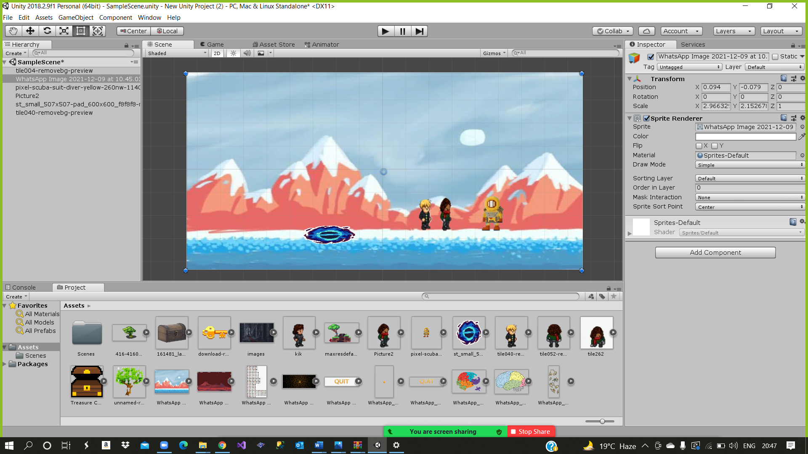

We used sketchbook and Adobe Fresco to draw for drawing:

1. **Formal Elements :**
   1. Mechanics:

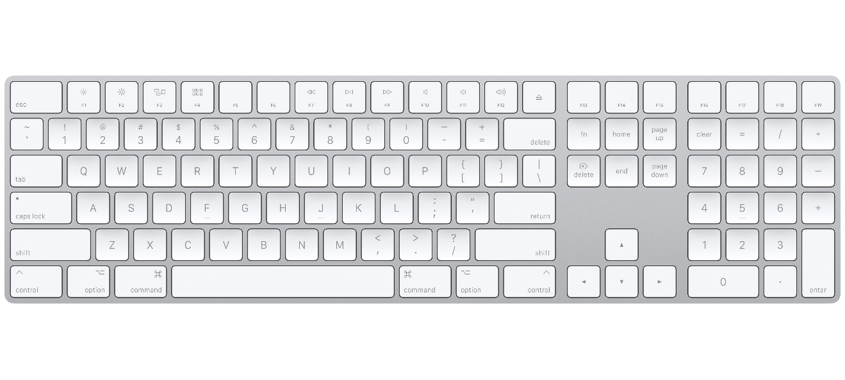

* **Walk** 🡪 **left and right**
* **Jump** 🡪 **space**
* **Shoot** 🡪 **Q**
  + 1. Player interaction pattern:
* Single player: in order to achieve a room and go to the next room, the player have to find a key (doesn’t have to be a key, it may be password)

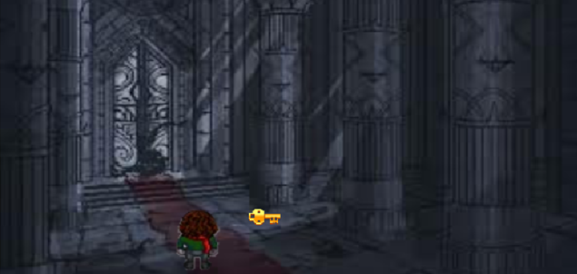

* + 1. Goals:
* The last level Zoey should find the designer and kill him
* Mandatory:

1. The playing character must find the game objects in a specific sequence
2. The player shouldn’t collide with any enemy

* Auxiliary:

1. In the last level, the player may kill the guards.
2. Pick up the thrown arrows in order to reuse it.
3. The player may pass throw any obstacle
   * 1. Rules:

* The player should survive the challenges in specific time
* If the player exceeded 3 lives, he/ she will return to a specific checkpoint
* In the first two levels the player should find the key for the next room



* + 1. Actions and interactions:
* Flowcharts :

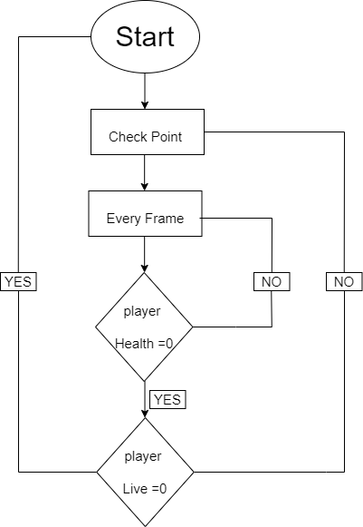

* When the player dies, the game will check if the player have health or no and if he don’t have the game will check the live if the player didn’t use it, the player will return to the checkpoint and if he use it before, he will start again from the beginning.

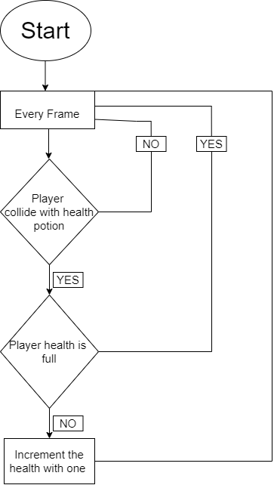

* When the player collide with health potion, the game will check if he need more health or no, if yes his health bar will increase by one, if he don’t need it, so the game will be continued without any interruption.

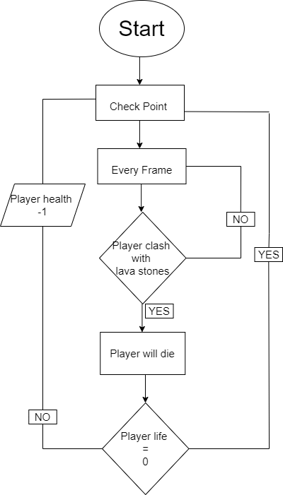

* When the player clash with the lava stone, player will die. The game will check his health, if he have; one will be decrease, if he do not have, he will start again from the beginning.

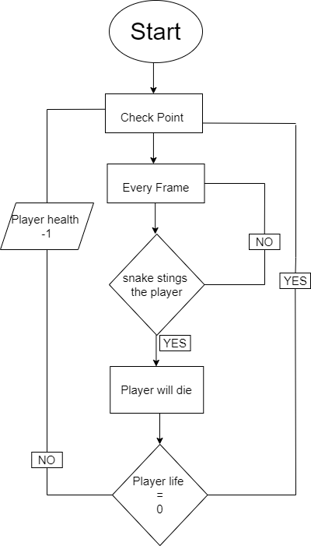

* When the snake stings the player, he will die, on the other hand the game will check his health, if he have it will decrease by one if he do not have, he will start the level from the beginning.



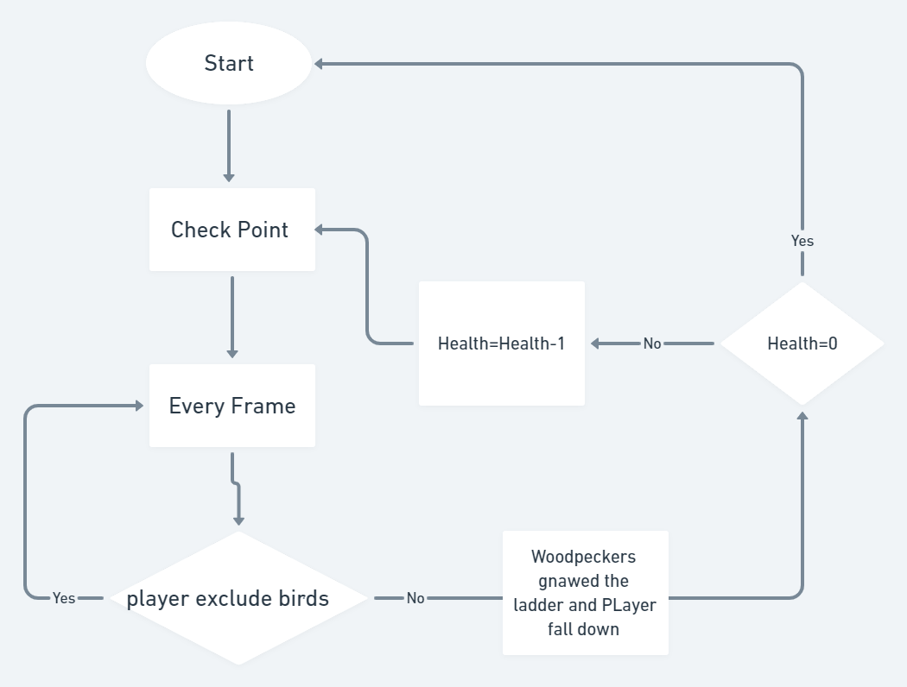

* **Level two: If the player excludes the birds, then he can get the lost number. if he is not, then the woodpeckers gnaw the ladder. So the player falls down, lost one health and returned to the check point or to the start if the health is equal to zero.**

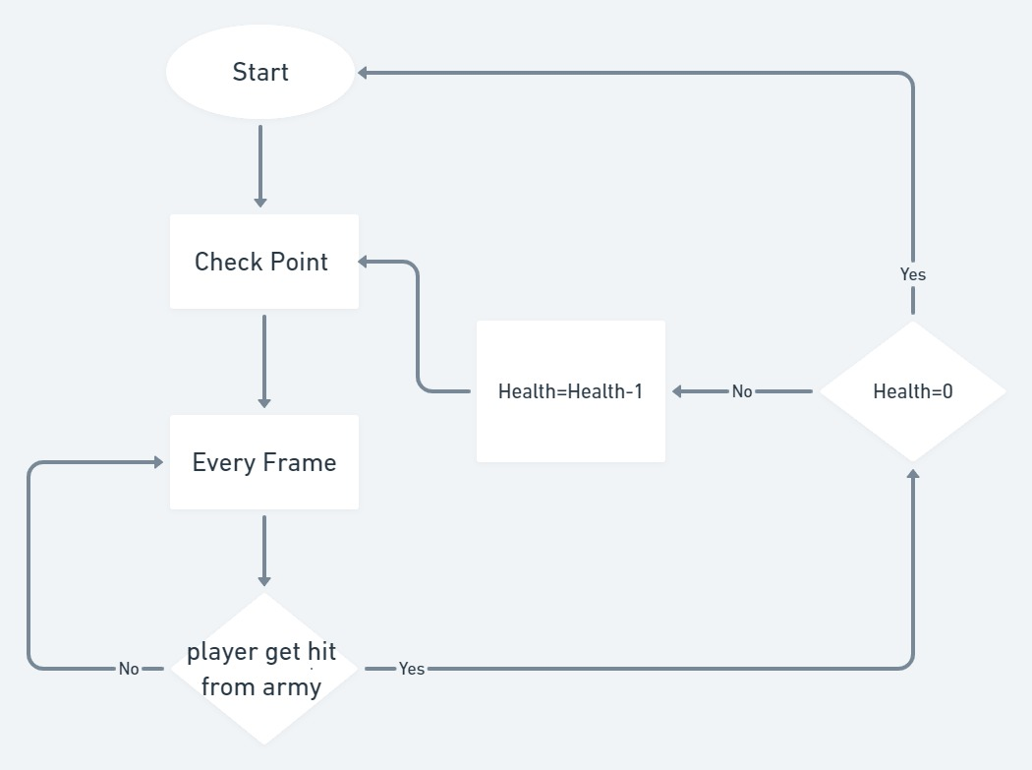

* Level two: If the player gets a hit from one of the skeleton armies, then he lost one of his health and returns to the checkpoint if the health is not equal to zero.

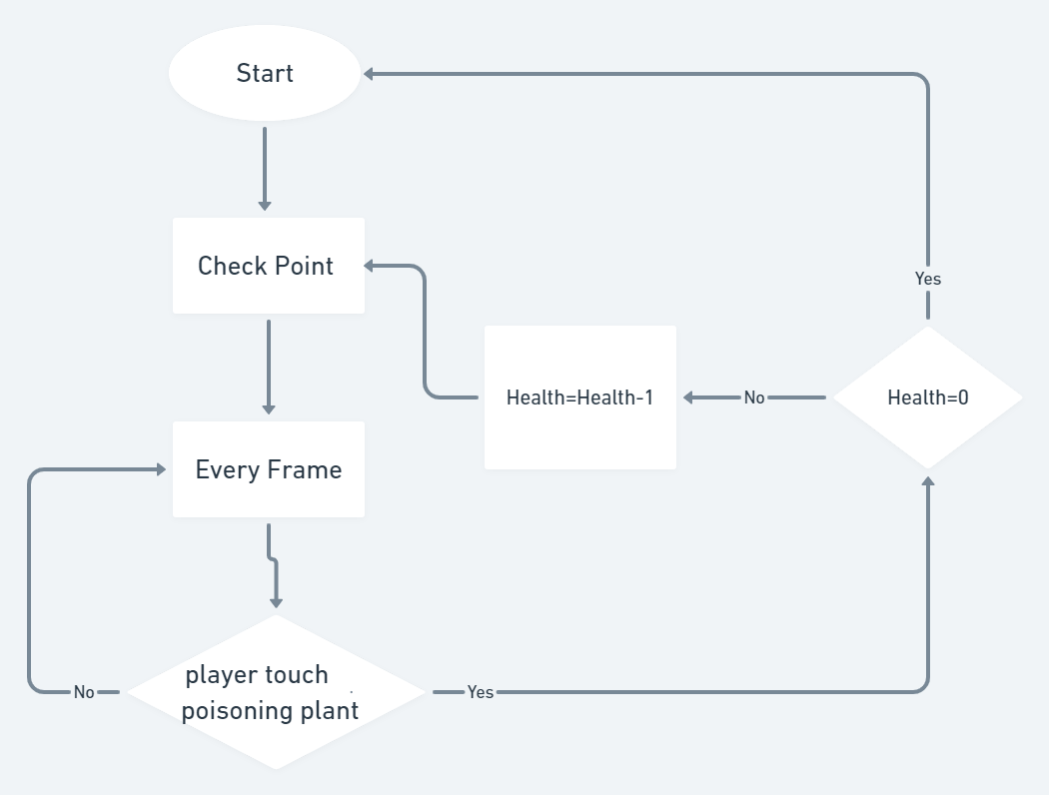

* Level two: If the player touches the poisoning plant, then he lost one health and returns to the check point or to the start if health is equal to zero.

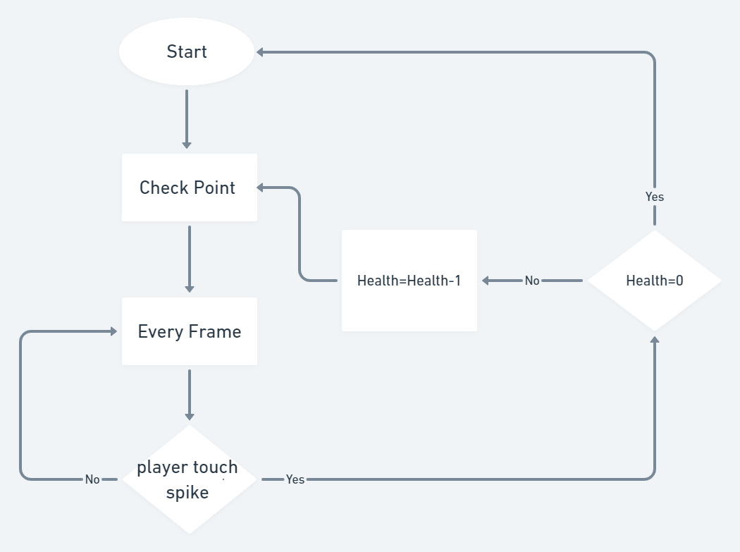

* Level two: If the player touches the spike, then he lost one health and returns to the checkpoint or to the start if he has not any health. Else, he will complete the level.

* In level 3 scene 2: if the player finds a map part and click on it the map parts counter will increase by one and if the map counter = 4, then a green arrow will be displayed on the map showing the designer’s direction.

* In level 3 scene 2 the if the player got killed from a guard and his/her health = 0, the player will return to the beginning of the game but if the health not = 0 the player will return to a specific checkpoint and the health will decreases by 1.

* If the player collides with a green anomaly the player’s speed will be doubled, if not the player’s speed will not change.

* If the player collides with an orange anomaly the player’s ammo will increase by 1, if not the player’s ammo count will not change.

* In level 3 scene 1 the if the player collides with a sea monster and his/her health = 0, the player will return to the beginning of the game but if the health not = 0 the player will return to a specific checkpoint and the health will decreases by 1.

* In level 3 scene 1 the if the player collides with a seaweed and his/her health = 0, the player will return to the beginning of the game but if the health not = 0 the player will return to a specific checkpoint and the health will decreases by 1.

* In level 3 scene 1 the player must search for the key and find it within a limited time (2 minutes) he/she can’t exceed that amount of time. But if he/she exceeds the limit and the if the health equal 0 will start the level from the beginning but if the health is not equal 0 then will return to the nearest checkpoint and decreases the health by 1.

* In the last level scene 2 Zoey will have to kill one guard in order display the first riddle in finding the designer.

* + 1. Challenges:
* Puzzle room (level 1 scene 1):

1. Lava stones which will be thrown on the players throughout the level, every time a stone hits a player the health will be equal to health -1, once the health will be equal to 0 the player will return to a checkpoint.
2. If the player exceeded the limit of the time, he/she will return to a specific checkpoint.

* 5 items room (level 1 scene 2):

1. If the player exceeded the limit of the time, he/she will return to a specific checkpoint.
2. Snakes would kill the player if they touched him/her

* Key keeper fight (level 2 scene 1):

1. Spikes when the player collide with them returns to a specific checkpoint.
2. If the player exceeded the limit of the time, he/she will return to a specific checkpoint.
3. Skeleton king with his army

* Maze (level 2 scene 2):

1. Poisoning plants the health will decrease by 1 each time a player collides with these plants.
2. 2 Soldiers will kill the player so the player will return to the beginning of the scene.

* Freezing room (level 3 scene 1):

1. sea monsters will paralyze the player under the water giving him/ her no chance but to drown.
2. Seaweed will catch any player who will come near It, suffocate them under water till death.
3. If the player exceeded the limit of the time, he/she will return to a specific checkpoint.

* The designer level (level 3 scene 2):

1. Guards will kill the player once they come near him/her.
2. If the player exceeded the limit of the time, he/she will return to a specific checkpoint.
   * 1. Resources:

* Health 🡪 each time the player dies the health will be health -1 and the player will return to a specific checkpoint
* Health potions 🡪 the player will take it to increase his/her health.
* Money 🡪 level 2 scene 1, the player must gather the coins because the coins will help him/her get a weapon as it will help in fighting the skeletons.
* Super speed orange anomaly 🡪 in the last level last scene, it will multiply the player speed by 2
* green anomaly 🡪 in the last level last scene, it will give the player more ammo or a new weapon.
  + 1. Player Mode Sketches:

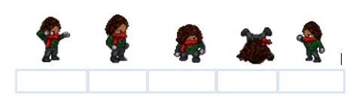

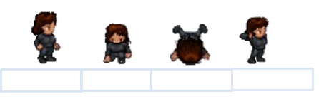

* + 1. Audio: https://drive.google.com/drive/folders/1HGWOxUJZTKmL_zTKGfdfvkoP8E0fCqx5?usp=sharing
    2. Outcome: The game will end with the death of the room designer.

1. **Dynamic Elements:**
   1. The sequence of events that take place in the story:

The story begins when all the players receive the invitation from the psychopath engineer. Out of curiosity, all the six players come and try to pass every level to win the award ($10,000). The rules of the rooms are simple find the key open the door and go to the next room solve the riddles find the key and so on. They thought that its an original escape room, but it turned out to be a life-threatening game, they started dying one by one from different enemies in different rooms till the last one Zoey, she decided to search for the game designer and kill him, she will find him in Rome chase him and kill him as a revenge for all the people he murdered.

* 1. Behavior and relationships between game entities and characters:
* **Player control object:** for example BoxCollider2D, RigidBody2d, Player Controller Script (It controls the animation, speed of the movement, jump height, and the control buttons that will be applied on the character).
* **Power Ups:** 1- Health Potions: It will be distributed among the game if the player catch it; the health bar will be recharged.

2- Collecting Arrows: Zoey will collect some of the arrows, . \ while she is trying to kill the game designer to avoid losing the level

* **Enemy Units:** In level one, first scene there will be lava stone that will kill one character; in the second scene, there will be snake that will kill the second character. In level two, first scene there will be either spikes or skeleton with his army that will kill one character. In the second scene, there will be either poisoning plants or soldier that will kill the forth character. In the level three, first scene there will be sea monster and seaweed one of them will kill the fifth character. Finally, in the last scene Zoey will start to search for the game designer and kill him.
* **Obstacles:** lava stones, snake, spikes, skeleton with his army, poisoning plants, soldier sea monster and seaweed, guards.
* **Sound effects:** There will be a sound in the background of the game also there will be in every action is taken like jumping, walking, collecting health and arrows achieving the level and at the end there will be sound effect when Zoey kills the game designer.



* 1. The objectives and the details of what happens in each level:
* Level One:
* **Scene one:** When the player start the level, he/she will find a guide person holding a chart that includes a message “The Key in the Bag “. Moreover, he/she must get the key in a limit time. The Player will start to search for any clue to help him/her how to find the key. First, the player will find a bag, and then when he/she click on it, he/she will find a puzzle that must be solved to help him/her in finding the key. The puzzle will zoom in to be clear to the player to know how to solve it. While solving it there will be some rocks that will fall from volcano, if it fall on the player, he/she will lose one health. The player will have three health if he lose all of them he will start from the checkpoint again; on the other hand, if he passed from the rocks and solved the puzzle there will be a clue that will let him try to find the key. The clue will be the picture that is on the puzzle. In our room, we will have an object that will be the same as the picture, the player will search on it, and then when he fined the object the key of the room will be inside, so the player will take it and open the door to pass the level.
* **Scene Two:** The player will start the level with a guider that is giving him a hint message “You Must Collect Five Items related to each other”. Moreover, he must get the door password to open it in a certain time, but if he take more than this time, he will start again from the checkpoint. In addition to there will be a snake and if it touches the player he will lose one health every time until he loses all the health and start again from the beginning. The player will start to search about the first thing, while searching he will find a riddle on the wall “There is a paper that include shapes and numbers”. He will keep searching until finding the card paper. The player will take it and think about the guider message, and then he will start to search again for something that is related to the card paper, after searching, he will find the card paper box and inside it, there is an hour hand. What this symbolize for, it symbolizes for a clock, so he will start searching for a clock or something related to it. The player will find a clock, inside the clock there numbers so he will search for anything that is related to numbers, on a wall there will be a mathematical equation that must be solved, because the solution of the equation will be the password of the door.
* Level Two :
* Scene One:FORESTthe player must collect the lost numbers to know the password of the door within the time of the level and throughout the scene he faces some of challenges like a poising plant which is one of the places that contains one lost number first the player should get a glove to protect himself from the poising plant, which contains one of the lost numbers

second two soldiers that were hidden in some place appears and fight the player so he should fight them using his weapon, third a huge and long tree contains angry birds and the last number of the password however the player should get a ladder to climb the tree and exclude the birds to get last number.

* Scene Two: the start of the level is player jumps up on some heights to collect a specific number of coins; these coins help him to get a weapon. the weapon will be used in fighting the army of the Skeleton. If the player takes one hit from the army, he loss one of his health and return to the nearest check point. Also, Throughout the fighting the player faces spikes; If the player touched one of these spikes, he loss one of his health and returned to the nearest check point. Finally, when the player killed all the army and reached to their king who has the key of the room, therefore the player also killed him though the time of the level.
* Level Three :

1. Scene One: The frozen room, in this room they will be in a totally frozen environment, at first, they must solve a riddle “At the bottom of every ocean there’s an answer”; they will then find out that the ground of the room is not just a normal ground, it’s a frozen lake, then they have to search for a sharp tool to break into that lake, once they found a hammer under a frozen tree a green boarder will be set on the exact spot they will drill a hole into that spot by just clicking on it, a diving suit will appear with a shiny green boarder in order to catch their attention. Because Danny is a video games obsessed and nerd he will say “that a healthy human being can survive under freezing water for approximately 2 minutes”. When the player clicks on the suit, the environment will change to into a total watery environment and the player will be wearing this suit. He/she will dive into the bottom of the lake searching for the key. But it will not be that easy, he/she may face some difficulties in achieving his goal, first the time will be limited 2 minutes then he will lose an amount of his/her health and return to a checkpoint which will be the start of the 2nd environment. Second 3000-year-old creatures, people thought were a myth; these sea monsters have the ability to paralyze people so they could drown. Third the seaweed plants can catch any creature and hold it under water till death.

* Scene Two: The last scene in the game mainly will take place in Rome as Zoey found out that the game designer residential place is in a mansion in Rome, the scene will start with a cut scene she was at her mother’s grave when she got an anonymous phone call with someone saying “I know where to find him, he is in a great mansion in Rome, sitting on his couch watching you and your friends suffer for your lives from his 292 inches TV”, she starts panicking asking him who are you, how do you know me, he hung up, then she packed her stuff heading to Rome, she landed in front of the greatest mansion in Rome, asked about the game designer if he lives in this mansion. The anonymous person called again saying” it is your biggest mistake” and hung up. She was so scared and confused, she didn’t understand what he meant by saying that. The playing mood starts on her landing in front of another mansion in Rome but this time as soon as the guards saw her, they started chasing her. The player here must realize the meaning of what the anonymous person said earlier. The player must know that the designer knows everything happens in Rome especially when it’s a news of someone searching for him, Zoey then starts a journey of killing some guards, hiding from others, with some help and guides like an anomaly green if she takes it gives her an extra ammo, or new weapon, or if it is orange then it gives her super speed power. A hint will be displayed on the wall, which will be “I have cities, but no houses. I have mountains, but no trees. I have water, but no fish. What am I?”, the player should guess that it’s a map then Zoey will start looking for a map she will find them in quarters, she must find all the map parts to know the designer’s residential place. The player must solve a sequence of riddles to be able to find each quarter. The first riddle will be displayed after Zoey kills the first guard, which will be “A thousand wheels, but I do not move. You call me a lot. What am I?”, the answer to this riddle will be parking lot, so she will find the first quarter at a parking lot. She must solve another riddle to be able to find the second quarter, which will be “I do not eat food. But I do enjoy a light meal every day. What am I?”, she must go search for a plant in which she will find the second quarter. The third riddle “What goes up when the rain comes down?” the player must search for an umbrella, the last riddle “What is more impressive than a talking dog?”, the answer is spelling bee so the player must search for bee hive, once the player collect the four parts of the map, a green arrow will be directed to the place where the designer will be found, then she could kill him and win the game or if she got killed from the guards she will return to a checkpoint till she loses all her lives and return from the beginning of the level
  1. cut scenes:
* The first level before scene 1:

All the players will receive a wooden box with the invitation inside, out of curiosity; they will go and start playing the game

* The last level before scene 2:

Zoey is at her mother’s grave when she got an anonymous phone call with someone saying “I know where to find him, he is in a great mansion in Rome, sitting on his couch watching you and your friends suffer for your lives from his 292 inches TV”, she starts panicking asking him who are you, how do you know me, he hung up, then she packed her stuff heading to Rome, she landed in front of the greatest mansion in Rome, asked about the game designer if he lives in this mansion. The anonymous person called again saying” it is your biggest mistake” and hung up. She was so scared and confused, she did not understand what he meant by saying that.

* 1. Guiders:
* In the first level the guidance will be with sound, when the player approaches the thing, he/she is searching about; a loud sound will play in the background.
* Non-playing characters
* Popups (riddles) indirect